IB Biology Name ________________________
Coordinated Movement Period ____ Date _____________

Introductory Questions:

- Which type of muscle tissue is attached to bone?

- Which type of muscle tissue is voluntary? What does this mean?

- What actions do muscles perform? (there are only two)

- What function do bones serve to movement?

- Why are muscles attached across joints?

Directions: On the diagram below color: muscles purple
ligaments pink
tendons blue
bones orange
nerves brown
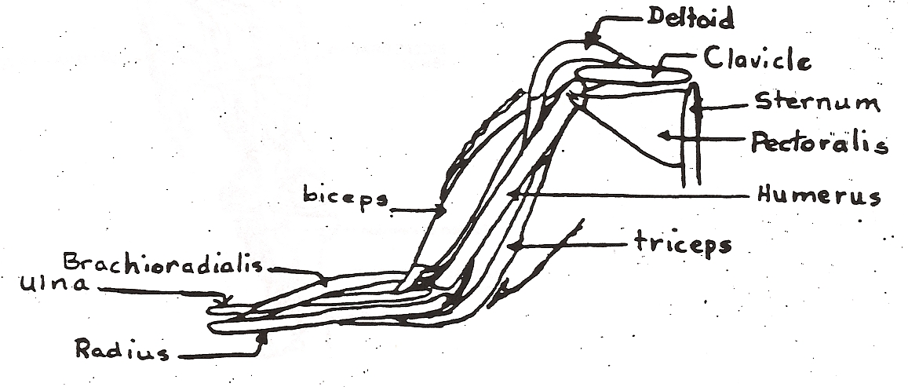

Actions:

6. Observe the actions demonstrated by the teacher. In each case, which muscle is contracting?

A. B. C.

- Describe the antagonistic relationship of the biceps and triceps.

- What is the common name of the joint involved in the actions of the biceps and triceps?

- In a paragraph on the back of this page describe the steps involved in bending the arm. Include the participation of bones, joint, tendon, nerve, brain, heart, lungs, and blood.

Electron Micrograph of Muscle Fiber


Detailed Diagram of Human Arm

